Mount Alexander Shire Council

Draft Asset Plan 2022 - 2026

February 2022

Contents

Contents 2
Document Control 3
1 Executive Summary 4
2 General 5
2.1 Introduction 5
2.2 Background 6
2.3 Legislative requirements 7
2.4 Framework 7
2.5 Purpose 8
3 PROCESS 9
3.1 Asset Management Planning Process 9
3.2 Asset Management Process 9
3.2.1 Asset lifecycle 9
3.2.2 Asset condition 10
3.2.3 Asset hierarchy 10
3.2.4 Levels of service 11
3.3 Asset Treatment 12
3.3.1 Maintenance 12
3.3.2 Renewal and replacement plan 12
3.3.3 Acquisition/ expansion upgrades (new works) 12
3.4 Disposal 13
4 Stakeholders 13
4.1 Internal Stakeholders 13
4.2 External Stakeholders 14
5 Asset Overview 15
5.1 Asset classes 15
5.2 Asset Class Description 15
5.3 Exemptions to Municipal Assets 16
5.3.1 Bordering municipalities 16
5.3.2 Arterial roads 16
5.3.3 Crown land 16
5.3.4 Rail 17
5.3.5 Utility services 17
5.3.6 Private streets 17
5.3.7 Road reserve assets not maintained by Council 17
6 Asset Management Performance 18
7 Risk management 18
8 Future demand 18
8.1 Demand forecast 18
9 Financial management 19
9.1 Life cycle costs 20
9.2 Lifecycle management plans 20
9.3 Funding strategy 20
9.4 Valuation forecasts 21
9.5 Capitalisation 21
9.6 Insurance 21
Plan for Improvement 21
10 21
10.1 Review 22
11 Definitions 22
12 References 23
ANNEX A – IMPROVEMENT PLAN 25

Document Control
Version | Date | Details | Author | Endorsed
V2.1 | October 2015 | AM Plan adopted by Council | Asset Management Coordinator | Mount Alexander Shire Council

Executive Summary
The Asset Plan provides direction to manage Mount Alexander Shire Council’s asset portfolio so that it best meets the service delivery needs of the community both now and in the future, and to ensure the requirements of the organisation’s Asset Management Policy are being adhered to.
Council recognises that sound asset management practices are essential to the quality and sustainability of the built environment, and necessary to the delivery of services that are consistent with the vision and goals encapsulated within the 10 year Community Vision and four year Council Plans.
This Asset Plan forms part of the overall Council Asset Management Framework. The Framework encompasses Council’s Asset Management Policy, Asset Plan and individual Asset Management Plans.

COMMUNITY VISION 2031
ASSET MANAGEMENT FRAMEWORK
Part 1  Asset Management Policy  (Drives Asset Management) | Asset Plan  (Ensures sustainable progress forward for asset management within available resources) | Asset Management  Plans
 |  | • Levels of service • State of assets • Financial modelling • Asset category improvement actions
FINANCIAL PLAN
Figure 1 - Council Asset Management Framework

The purpose of the Asset Plan is to establish the status, vision, and actions for managing the asset lifecycle across Mount Alexander Shire.
The asset management planning process defines the service needs and legislative requirements and incorporates these needs into the Council’s strategic documents.
Mount Alexander Shire Council (MASC) is responsible for the management of infrastructure assets including roads, bridges, drainage, buildings, plant and equipment and open space, with a total replacement value at 30 June 2021of $451 million.
MASC will continue to deliver best practice asset management solutions through the implementation of improvement plans, detailed within individual asset management plans, which prioritise the strengthening of core asset management processes.

General

Introduction
The Mount Alexander Shire is located in the central part of the state of Victoria.
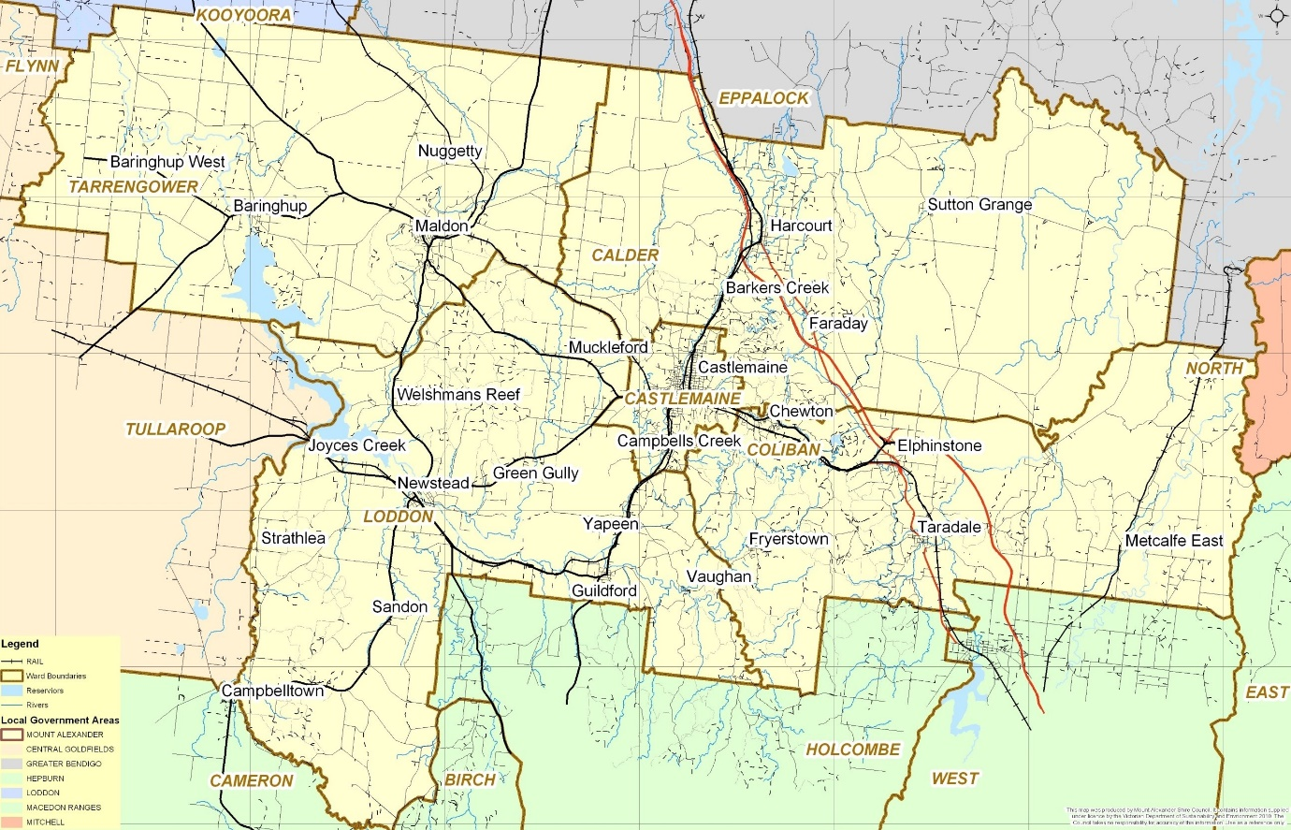
Figure 2 - Mount Alexander Shire
The Shire includes the towns of Campbell’s Creek, Castlemaine, Chewton, Elphinstone, Fryerstown, Harcourt, Maldon, Newstead, Taradale, and Vaughan. An overview of the Shire’s population is provided in the following statistics:

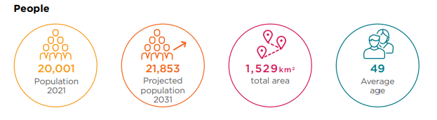
Figure 3 - Population Statistics

This plan aligns the MASC vision ‘Working together for a healthy, connected shire’, with the strategic action for asset management ‘Review, maintain, renew and expand sustainable assets of our community’ and outlines the activities that need to be undertaken to achieve the continued implementation of Council’s Asset Plan
The Asset Plan is complemented by Asset Management Plans for each asset class with the goal being to optimise the lifecycle value of assets sustainably over the long term in the best interests of the community.

Background
Council is committed to continually improving its approach to asset management. Council is responsible for the management of infrastructure assets with a total replacement value at 30 June 2021of $451 million.

Asset Class | Description | Replacement Value as at 30 June 2021
Roads | Gravel and sealed roads | $225,686,465
Pathways | Footpaths and managed trails | $10,088,853
Bridges | Bridge and major culvert structures | $71,136,477
Drainage | Drains, pits, culverts, kerb and channel | $58,815,460
Open Space |  | $5,050,057
Buildings and Facilities | Council owned buildings and facilities | $73,329,808
Plant and Equipment | Minor and major plant and equipment. IT infrastructure | $6,936,143
TOTAL |  | $451,043,263
Table 1 - Asset Class Values

Since 2012, our objective has been the improvement and maturity of Council’s asset management practices. This has included implementing the following:

- Alternative treatment options.
- Long-term cash flow predictions.
- Defined levels of service.
- Maintenance management systems.
- Condition assessments.
- Asset risk assessments.

In 2015, the Asset Management Policy was reviewed based on previous plans and subsequently adopted by Council. More recently the Asset Management Policy was reviewed along with a number of Asset Management Plans. Some have been adopted others are waiting to be finalised.
During this time, Council also implemented a new Asset Management Information System to address numerous inefficiencies in managing asset data.

Legislative requirements
Legislative and regulatory requirements collectively direct MASC to provide safe, relevant and responsive infrastructure assets which consider the current and future needs of our community.
Legislation | Requirement
Road Management Act 2004 and associated Regulations and Codes of Practice | Purpose is to establish a coordinated management system for public roads that will promote safe and efficient State and local public road networks and the responsible use of road reserves for other legitimate purposes, such as the provision of utility services.  Defines the responsible authorities for all roads within the state. It makes council the controlling authority for public local roads, boundary roads and parts of declared roads within the municipal area and it is therefore responsible for managing the Infrastructure assets within them.
Local Government Act 2020 | Sets out role, purpose, responsibilities and powers of local governments including the preparation of a long term financial plan supported by asset management plans for sustainable service delivery.
Transport Act 1983 | Sets up structure for the provision and regulation of public and commercial transport.
Road Safety Act 1986 | Safety requirements relating to the use and operation of the road network
Road Safety Regulations 2009 | Sets out regulations for implementing the Road Safety Act.
National Asset Management Framework Legislation 2010 | Focuses on long term financial sustainability and provides a mandate to have long term strategy, financial statements and annual reporting mechanisms in place. Asset Management plans may be audited.
Occupational Health and Safety Act 2004 | Aims to secure the health, safety and welfare of people at work. It sets out general requirements which must be met at places of work in Victoria.
Occupational Health and Safety Regulations 2007 | Outlines minimum actions to be taken to comply with OH&S Act. It explains inspection, testing and WorkCover registration requirements for plan such as Lifts.
Disability Discrimination Act 1992 | Sets out the responsibilities of Council and staff in dealing access and use of public infrastructure.
Planning and Environment Act 1987 | Sets out the legislative requirements for planning and environmental concerns in new and upgrade areas of the shire. Allows for the impact of asset construction and growth and sets parameters to trigger Council activities/actions.
Mount Alexander Shire Council Local Law, such as the Asset Protection and Footpath Trading | Various local laws exist to protect the well-being of the community, the amenity of local neighbourhoods and the environment. Local laws guide communities on appropriate behaviour and actions, and they outline legally enforceable standards for issues such as:  Protection of our built and natural environment  Behaviour in public spaces  Neighbourhood nuisances  Safety concerns  Health matters

Table 2 – Legislative requirements

Framework
The Asset Management Framework will be monitored and implemented by the following groups:
- Asset Management Steering Committee
- Asset Management Working Group

The Asset Management Steering Committee will provide strategic direction to support the implementation, review and monitoring of the Asset Management Framework. This will be made up of Executive Team members

The Asset Management Working Group will develop, coordinate and support the delivery of actions to improve asset performance and utilisation measures, with service management and financial sustainability the driver of asset management planning.

The following documents form the Asset Management Framework:
- Asset Management Policy – MASC’s commitment to manage its assets in a sustainable way, to assist in the achievement of the 10 year Community vision and meet the service and infrastructure needs of the community.
- Asset Plan - Establishes the framework for asset management in MASC.
- Asset Management Plans - Support the Asset Plan and the implementation of the Asset Management Policy with the provision of Levels of Service and overall lifecycle planning for all nominated asset classes. The current asset management plans are listed below:
  - Infrastructure
- Part A - Roads (DOC/20/52004 authored, not yet adopted)
- Part B - Pathways (DOC/20/14491 adopted June 2020)
- Part C - Bridges (DOC/20/14493 adopted June 2020)
- Part D - Drainage (DOC/20/30348 authored, not yet adopted)
  - Open Space (authored, for consideration at February 2022 Council Meeting)
  - Buildings (DOC/18/38910 authored, not yet adopted)
  - Plant and Equipment (not yet authored)

Purpose
The objectives of this Plan are to:
- Describe how MASC will meet its commitment to asset management as documented in its Council Plan and Asset Management Policy and the Local Government Act 2020.
- Optimise the lifecycle value of assets sustainably over the long term, in the best interests of the community.

PROCESS

Asset Management Planning Process
Asset Management planning commences with defining service needs and legislative requirements and incorporating these needs into the organisations strategic resource plan, developing an asset management policy, asset plan, asset management plans and operational plans, linked to the long-term financial plan.
An outline of the asset management planning process is shown below:
Implement Asset Management Solutions
Recording new acquisitions and disposals
Inspections, Maintenance and Renewal
Implementing enhanced software solutions
Strategic Planning Process
Community Vision
Council Plan
Long Term Financial Plan
Community Expectations
Levels of service
Cost

Legislative Requirements
Financial
Environmental
Asset Management Process
Asset Management Policy
Asset Plan
Asset Management Plans

Figure 4 - Outline of the Asset Management Planning Process

Asset Management Process

Asset lifecycle
The asset management lifecycle includes all management options and strategies required from planning to disposal. The objective of managing the assets in this manner is to look at long-term cost impacts (or savings) when making asset management decisions. The lifecycle is depicted below.
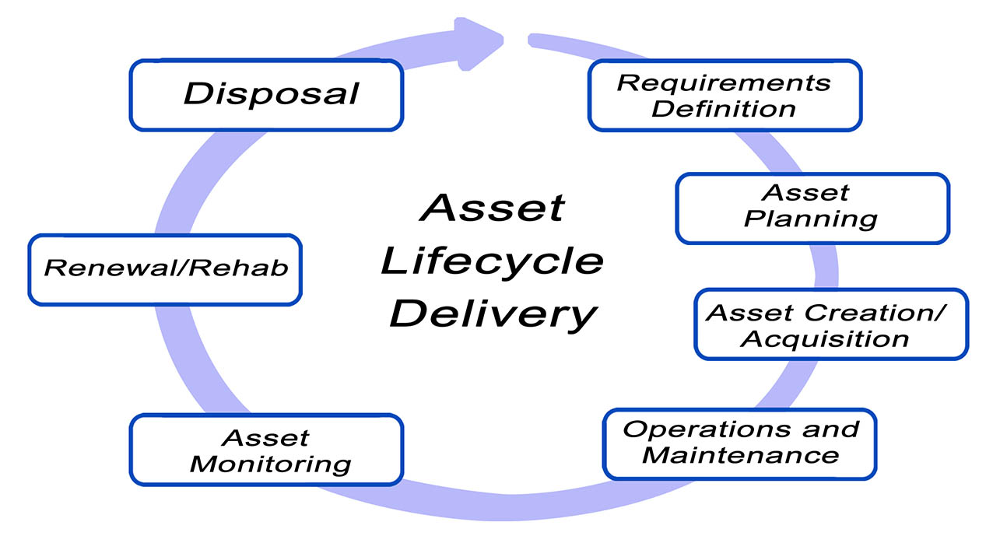
Figure 5 - The Asset lifecycle

Asset condition
Inspections of varying detail are required on a regular basis to monitor the condition and performance of Council assets in line with agreed Levels of Service. Additional condition inspections may be required after major floods or fire events or to coincide with asset revaluation requirements.
Council commissions a comprehensive condition inspection of all asset classes every 5 years.
Council’s overall condition rating scale is shown below.
Condition rating | Description | Condition
0 | New Asset | A brand new asset
1 | Excellent condition | Inspection in accordance with Council and legislative requirements minimum maintenance required
2 | Very Good | Minor maintenance required
3 | Good | Moderate maintenance required
4 | Average | Significant maintenance required capital renewal or upgrade may be required within the next 5 years
5 | Poor | Significant renewal/upgrade required within the following 2 years
6 | Very Poor | End of life no service potential left
Table 3 – Condition scores used in Assetic

Asset hierarchy
An established asset hierarchy for each asset ensures that appropriate management, engineering standards and planning practices are applied to the asset based on its function. This enables more efficient use of limited resources by allocating funding to those assets that are in greater need and the costs are better justified.
An example of asset hierarchy for the Road Asset Class is shown below:
Priority | Classification | Description
1 | Link Roads | They provide links between townships, communities and highways. They have significant traffic volumes including high numbers of commercial vehicles.
2 | Collector & Strategic Roads | Connect smaller communities and industrial areas and act to feed link roads.
3 | Local Roads | Provides general vehicle access to abutting properties. They have lower traffic volumes than the previous categories.
4 | Minor Roads | Similar to a local road but typically in a rural area servicing more sparsely located properties
5 | Unformed Roads | They are usually unmaintained tracks that are not on the Councils road register
Table 4 - Example of the Road Asset Hierarchy
Typically the higher the priority in the asset hierarchy the higher the service level requirements and subsequently higher investment requirements.

Levels of service
Levels of Service is the defined quality of service of an asset. Understanding the required level of service is vital for lifecycle management, as this largely determines an asset’s development, operation, maintenance, replacement and ultimate disposal. The level of service of an asset is further defined by:
- Community level of service
- Technical level of service
- Operational level of service
- Legislative requirements
They define the target performance standards for assets of a given type. The development and implementation of Levels of Service require ongoing, continuous improvement.
Asset management planning requires a balance between the level of service expectation by the community and the actual level of service that can be maintained based on financial and legislative requirements.
Achievement and sustainability of services requires funding for routine preventative and responsive maintenance as well as for timely renewal or replacement of the asset. Adequate financial resources ensure that assets are appropriately managed and preserved.
Poor management practice and/or limited financial allocations for maintenance, renewal and replacement that do not meet the required Level of Service have a direct impact on the Council’s vision of a healthy and connected community.
If prolonged, such practices will result in a substantial need for ‘catch up’ expenditure which is commonly imposed on ratepayers in the future. Additionally, deferred renewal results in increased and escalating reactive maintenance as aged assets deteriorate at increasing rates.
Levels of service to date have been developed on the basis of available funding through the annual budget process.

Asset Treatment

Maintenance
Routine maintenance is required to keep assets operating efficiently, and identify instances where portions of the asset fail and need immediate repair.
Maintenance includes reactive, planned and cyclic maintenance work activities:
- Reactive maintenance is unplanned repair works due to failure of an asset and typically has immediate impacts on the service or safety of users of the asset.
- Planned maintenance includes items that are found through routine inspections and general operation, and have high priority or impact, but pose no immediate threat to service or safety.
- Cyclic maintenance is the service or replacement of an asset component recognised through inspections undertaken on a regular cycle.
MASC is responsible for funding maintenance on all its assets. Maintenance plans for each asset class are detailed in the relevant sections of their associated Asset Management Plan.

Renewal and replacement plan
Renewal expenditure is major work that does not increase the asset design capacity but restores, rehabilitates, replaces or renews the asset to its original capacity. Work over and above restoring an asset to original capacity is classified as upgrade expansion or new works.
Renewal works are identified as part of the capital works program and within the annual Council budget, and may be funded by Council or through a combination of grant funding and Council funding.
Renewal works may include:
- Rehabilitation to rejuvenate an asset to its originally designed purpose so that it can meet an agreed Level of Service.
- Replacement to provide a new asset with the equivalent size or capacity.
Renewals are capitalised at the end of the project so that the cost can be depreciated over the future life of the asset.

Acquisition/ expansion upgrades (new works)
New works are those that create a new asset that did not previously exist, or works which upgrade or improve an asset beyond its existing capacity or performance. These improvements may result from changes in use or increased Levels of Service.
New works include assets constructed as part of a residential or industrial subdivision by developers and vested in Council.

Disposal
Disposal includes any activity associated with discarding a decommissioned asset including sale, demolition or relocation. The disposal option requires careful consideration in service reviews and consideration of non-asset based service delivery.
Rationalization of assets in this way eliminates future life-cycle costs associated with disposed assets.

Stakeholders
Stakeholder roles and responsibilities are listed below.

Internal Stakeholders
Councillors
- To act as custodians for assets;
- To adopt the Asset Plan;
- To adopt functional service levels; and
- To adopt risk and cost standards.
Audit and Risk Committee
- To consider audit and risk reports prepared relating to asset management and make recommendations to Council as appropriate.
Chief Executive/Director of Infrastructure
- To oversee the Asset Plan development for Council adoption;
- To implement the Asset Plan with agreed resources;
- To monitor and review the performance of Council’s Managers and staff in achieving the Asset Plan;
- To ensure appropriate resources and funding for asset management activities;
- To ensure the presentation of accurate and reliable decision making information to Council;
- Report to Council, annually, on the status, progress and resource requirements for implementing the Asset Plan; and
- Promote and raise awareness of asset management to the Council, staff and community.
Managers and Staff
- To implement the Asset Plan;
- Use the lifecycle analysis to develop the Asset Plan for individual asset classes;
- To implement continuous improvement in the management of asset classes;
- To determine and deliver asset levels of service to agreed risk and cost standards;
- To manage assets in consideration of long term sustainability; and,
- To present information to the Councillors, Chief Executive and Directors in terms of lifecycle risks and costs.
Asset Management Co-ordinator
- Asset management subject matter expert on behalf of Council;
- Responsible for the administration of the Asset Plan;
- Annually report on the status, progress and resource requirements of implementing the Asset Plan to the Executive for reporting to the Council;
- Administer the asset management system;
- Advocate, encourage and guide the development of processes and procedures that allow for the ‘whole of life’ and continued management and ownership of assets, including all asset lifecycle management functions;
- Advocate a common and consistent approach to asset management across all assets.

External Stakeholders
- Residents, Ratepayers and Asset Committees;
- Traditional Owner Groups and Corporations;
- Advisory Committees;
- Friends Groups;
- Land Care Groups;
- Facility User Groups;
- Tenants;
- Tourists and visitors;
- Business community; and
- External Agencies (such as State and Federal government, EPA, VicRoads, Workcover, Insurers, Health Service Providers

Asset Overview

Asset classes
MASC is responsible for assets with a total replacement value of $451 million (June 2021). Asset classes and valuations are in the following table.
Asset Class | Description | Replacement Value as at 30 June 2021
Roads | 1,440km of gravel and sealed roads | $225,686,465
Pathways | 33km of footpaths and managed trails | $10,088,853
Bridges | 242 bridge and major culvert structures | $71,136,477
Drainage | 145km of drains  4,425 pits | $58,815,460
Open Space | 54 active park areas  597 passive park areas | $5,050,057
Buildings and Facilities | 238 Council maintained buildings  72 Other structures | $73,329,808
Plant and Equipment | Minor and major plant and equipment. IT infrastructure | $6,936,143
TOTAL |  | $451,043,263
Table 5 - Council Asset Classes

Asset Class Description
- Roads - Sealed and unsealed roads, footpath, kerb and channel,
- Bridges – Bridges and major culvert structures
- Stormwater drainage - stormwater pits and pipes, minor culverts, retarding basins and open drains,
- Buildings - commercial and civic buildings, community buildings; youth service centres, public conveniences and recreational facilities,
- Open spaces - open and active spaces including streetscapes, passive reserves, sportsgrounds and recreation assets including park furniture, ancillary items, play spaces and public lighting. This asset class includes the financial valuation of land improvements and site improvements,
- Plant and equipment - vehicle plant, machinery plant and minor equipment, IT equipment, furniture and fittings,

Exemptions to Municipal Assets

Bordering municipalities
MASC shares common boundaries with the following municipalities:
- City of Greater Bendigo
- Loddon Shire Council
- Central Goldfields Shire Council
- Hepburn Shire Council
- Macedon Ranges Shire Council
- Mitchell Shire Council
Details of these agreed areas of responsibility are provided in agreements with each bordering municipality and noted in Councils Register of Public Roads.

Arterial roads
An arterial road may be a freeway, a declared arterial road or a non-declared arterial state road. VicRoads is the state administrator and manager for all declared arterial roads which include:
- Pyrenees Highway – B180
- Midland Highway - A100
- Castlemaine Maldon Road – C282
- Maldon Newstead Road – C283
- Maldon Bendigo Road – C283
- Maldon Bridgewater Road – C282
- Creswick Newstead Road – C283
- Daylesford Newstead Road – C285
- Calder Highway (South of B180) – C794
Council will consult with external regulators to manage issues arising in areas where both Council and VicRoads hold assets.
In relation to arterial urban roads, hard copy sketches of the line of demarcation between Council and VicRoads have been developed based on the Operational Responsibility for Public Roads Code of Practice.
In rural areas, VicRoads is responsible for the full width of the road reserve, from property line to property line, with the exception of formal foot or shared paths where they exist on the verge of these roads.

Crown land
A number of roads are located on crown land managed by the Department of Environment, Land, Water and Planning (DELWP) and Parks Victoria. Where these roads do not service a MASC asset or ratepayer, the road may be the responsibility of the relevant Department. In some instances a road may pass through crown land and MASC may remain the responsible authority.

Rail
The relevant rail authority is responsible for the maintenance of the road and infrastructure in the immediate vicinity of a rail crossing and some bridge structures. The Rail Safety Act 2006 requires Safety Interface Agreements.

Utility services
The relevant service provider including water, gas, sewer, phone or power is responsible for the maintenance of its infrastructure located within a road reserve.

Private streets
A private street is a formed road on private title, built by a developer, private company or resident. Sometimes these are named and may have street name signs. These roads are not on a road reserve, nor are they a MASC asset. They are not maintained by, or the responsibility of MASC. As a result they will not be listed on the Public Road register and are not covered by this plan.

Road reserve assets not maintained by Council
There are a number of assets within the road reserve for which MASC is not the responsible maintenance authority. These include:
- Vehicle crossovers and driveways for that portion of a vehicle crossing, other than the footpath, located between the carriageway and the property boundary is the responsibility of the adjoining property owner to maintain.
- Nature strips and infill areas within urban areas which are those residual areas between the edge of the road or back of the kerb and the property boundary not occupied by the pathway and private road crossings. These are normally sown to grass with responsibility for maintenance of the grass and any depressions generally being left to the adjoining property owner.
- Single property stormwater drains that are constructed within the reserve from the property boundary to a discharge outlet in the kerb or into the drain. They are there to benefit the property and as such are the responsibility of the owner of the property being served to maintain.
- Private or illegal landscaping works on the road reserve that are not in accordance with any MASC policy on such landscaping or have a potential of causing obstruction or injury/damage to pedestrian or traffic movement.
- Street lighting (standard) maintenance of all utility timber and concrete power poles is the responsibility of power companies however maintenance of decorative poles in streetscapes is a MASC responsibility. Council is responsible for the cost of operating the street lighting service on local road reserves and contributes to the cost of lighting on arterial roads.
Council may also serve a notice on a service utility, authority or a property owner to repair, within a given period, a defect in the road reserve that has been brought to MASC attention.

Asset Management Performance
MASC has previously been part of the National Asset Management Assessment Framework and associated performance reporting however has not taken part recently. The Asset Management Working group will look for tools to assess improvements in asset management performance as part of the improvement plan in Annex A.

Risk management
The strategies outlined in this Plan seek to manage the following key risks:
- Providing a safe asset for all users – by maintaining agreed Levels of Service,
- Enabling the freight industry business continuity – by facilitating access to the road network and maintaining agreed Levels of Service,
- Minimising the contingent liability for future maintenance – by applying sustainable funding levels for all asset classes.
- Minimising exposure to litigation due to nonfeasance issues – by managing the road network according to a transparent and well-documented system which reflects contemporary asset management principles.
- Ensuring maintenance practices are environmentally sustainable and meet all legislative requirements – by appropriate works specifications and firm management of all asset-maintenance contracts.

Future demand
Future demand on assets is tied to the demand for MASC’s services combined considerations related to a number of socio-economic and environmental drivers outlined below.
Maintaining MASC assets without adequate regard for service needs may result in a well-maintained portfolio of assets, but it may also result in an asset portfolio which does not meet the needs of the community.

Demand forecast
Taking into account a service approach, future services will be driven by demand and utilisation. The demographic profile of the area is detailed in the document, the Mount Alexander Shire Council Community Profile draft February 2013.
When considering capital works and asset maintenance, the demand drivers include:
- Increased age of assets and remaining useful life of existing infrastructure
- Increased community expectation of accountability of asset maintenance
- Increased community expectation of service and amenity
- Improved Levels of Service
- Improved access to inclusive and connected spaces for the community
- Population and demographic changes
- Residential, commercial and industrial developments and the impact on existing infrastructure
- Climate change
- Technological changes
Demand for new services will be managed through a combination of managing existing assets, upgrading of existing assets and providing new assets taking into account:
- Transport strategies
- Community strategies/public education
- Sports and recreation
- Access to park land and open space
- Levels of Service
- Alternative means of movement
- Developer contributions
- Aging Buildings and Plant

Financial management
Financial modelling has been undertaken to determine funding needs for asset renewals over a 10 year period. A summary of the 10 year forecast financial expenditure has been provided from the data in the MASC Financial Plan 2021- 2031, see Figure 6 below.
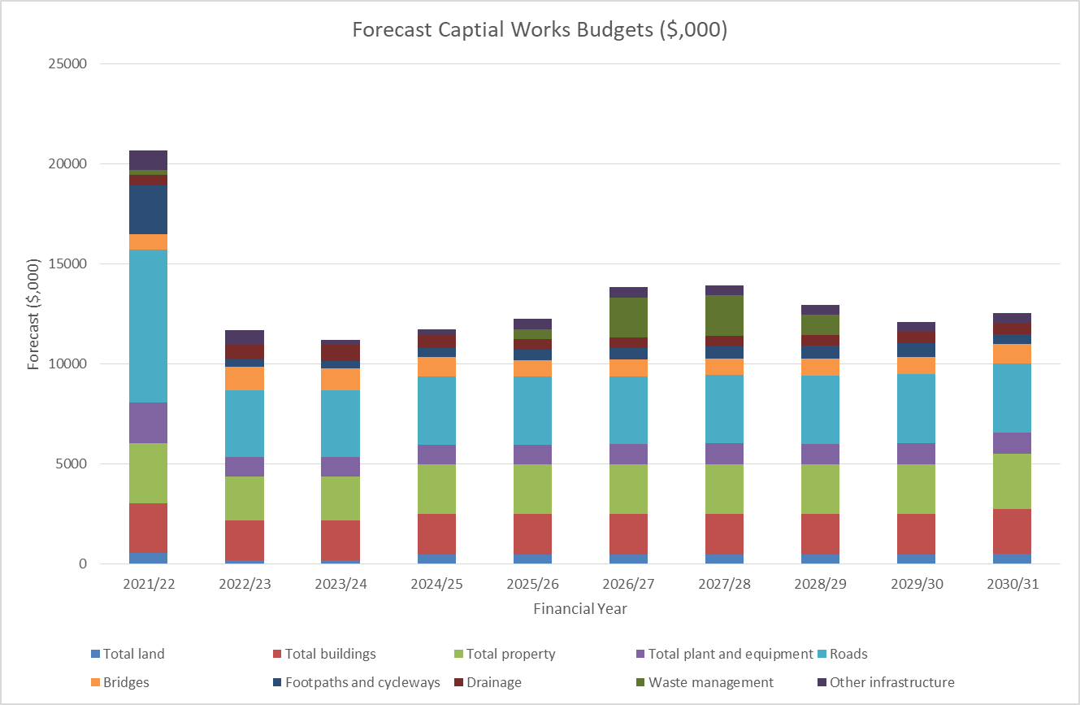
Figure 6 - Forecast Capital Renewal Budgets

The financial summary will be reviewed annually and be refined as planning studies, strategies and increased (more accurate) financial analysis are completed.

Life cycle costs
Life cycle costing is a process whereby all expenses associated with the asset are allocated to it so the true cost of service delivery to the community is known. These expenses include the capital cost of construction of an asset or asset class and also operations and maintenance expenditures which include the regular safety inspections.
Life cycle costs can be compared to life cycle expenditure to indicate sustainability in service provision. Gaps between life cycle costs and expenditure provide an indication as to whether sufficient funds are being allocated to cover the degradation of assets.

Lifecycle management plans
The lifecycle management plan outlines what management options and strategies are planned in order to manage the assets at an agreed level of service while optimising overall life cycle costs.

Funding strategy
The funding strategy is detailed in the MASC Financial Plan.
Sources for funding expenditure on assets include:
- Council rates revenue
- Federal Government funding (e.g. Roads to Recovery)
- Commonwealth Funding Grants Commission
- State Government grants
- Private developer funds for new or upgraded infrastructure, via direct funding or developer contributions
- Special charge schemes
The funding strategy to achieve priorities is confirmed and detailed in the long term financial plan.

Valuation forecasts
The value of MASC assets is calculated as at 30 June and reported in the MASC Annual Report. Current valuations are detailed in Table 5.
A valuation of each asset group is undertaken in accordance with the Fair Value principles required by the Auditor General. In addition adjustments are made to the valuations annually by reviewing construction unit rates and condition, and the addition of new or upgraded assets ‘at cost’ to the accounts.

Capitalisation
All asset creation, renewal, replacement and disposal that are valued over $10,000 are capitalised as part of Council’s financial requirements.
This ensures annual asset valuations are maintained and correct.

Insurance
MASC insures its assets for public liability risk through Jardine Lloyd Thompson. The insurer conducts bi-annual external audits for compliance and scores how well MASC manages risk. Councils risk manager has an overall responsibility for continuous improvement in risk management procedures.

Plan for Improvement
Council will continue to develop processes to deliver best practice asset management, taking into account budget constraints, resourcing and community expectations. Council’s Asset Management Steering Group will provide organisational wide strategic direction and leadership on matters relating to infrastructure asset management.
There are identifiable gaps between the current state and the desired future state of asset management for Council. These ‘gaps’ have been translated into actions which form part of the Asset Management Improvement Plan (refer to Annex A).
The asset management improvement plan identifies:
- Development of a lifecycle management plan
- Development of multi-year maintenance and capital works program
- Further refinement and improvement of the prediction modelling life-cycle paths and decisions

Review
As part of the improvement plan the MASC will work to implement performance monitoring and review across all asset classes, this will include:
- Monitoring and review of target Levels of Service identified in the Asset Management Plans.
- The degree to which the required financial allocations identified in the asset management plans are incorporated into MASC’s long term financial plan.
- Customer satisfaction:
  - MASC measures its performance using the annual Victorian Local Government Customer Satisfaction survey which provides statistics on Council’s rating out of 100 and how it has performed compared with other Councils.
  - Customer requests recorded in MASC’s customer request management system.
Regular review of the Asset Plan as highlighted in Table 6:
Activities | Frequencies
Asset Management Policy | Major Review and update every 4 years
Asset Plan | Major Review and update every 4 years
Condition Assessment | 2 years for bridges (Level 2 inspection) in drainage asset group  4 years for all other major asset groups
Asset Life review | Reviewed as part of the condition assessment.
Asset Revaluation | Indexed annually and formally revalued every 5 years.
Asset Management Plan | Update every 4 years
Table 6 - Asset Plan review frequencies

Definitions
Asset | A resource controlled by the entity as a result of past events and from which future economic benefits are expected to flow to the entity.
Asset class | A grouping of assets of a similar nature and use.
Asset management | A systematic process to guide the planning, acquisition, operation, maintenance, renewal and disposal of assets.
Levels of Service | The standard to which an asset needs to perform, and how quickly and to what standards it needs to be maintained.
Life-cycle approach | The process of balancing maintenance and maintenance expenditure with planned renewal of an asset, getting the longest possible useful life from an asset before it’s more economical to renew rather than continue to maintain and extend the useful life of an asset.
Useful life | The period over which an asset is expected to be available for use by an entity.
Maintenance | The activities required to repair asset defects, ensuring assets remain operational and reach their expected useful life. Spending on such is considered operational expenditure.
Renewal | Replacing an existing asset, ideally that has reached the end of its useful life, with a new version of that asset. Spending is considered capital expenditure.
Rehabilitation | Works to rebuild or replace parts or components of an asset to restore it to a required functional condition and extend its life.
Upgrade | Enhances and existing asset to provide a higher level of service and or increases its life.
Whole of Life | Includes all costs associated with the ownership of an asset that allows it to continue to function to meet service needs over its “life” including, planning/creation, operations, maintenance, renewal and disposal.

References
The following references are utilised in relation to Asset Management Planning:
- Mount Alexander Shire Council Plan 2021-2025
- Mount Alexander Shire Council Strategic Resource Plan 2017-2021
- Mount Alexander Shire Council Financial Plan 2022-2031
- Mount Alexander Shire Council Asset Management Policy
- Mount Alexander Shire Council Asset Plan
- Mount Alexander Shire Council Asset Valuation and Revaluation Policy
- Mount Alexander Shire Council Annual Report 2020/2021
- Mount Alexander Shire Council Risk Management Framework and Policy
- International Infrastructure Management Manual (IIMM), 2015
- Australian Infrastructure Financial Management Guidelines, 2015
- Municipal Association Victoria 2010, National Asset Management Assessment Framework
- Assetic asset management system
- Mount Alexander Shire Road Management Plan 2020

ANNEX A – IMPROVEMENT PLAN

No | ASSET MANAGEMENT IMPROVEMENT PLAN | RESPONSIBLE SERVICE UNIT | Target date
 | Strategic context
1. | Complete Asset Management Plans for all outstanding asset categories and implement.  - AMP - Roads (DOC/20/52004 not yet adopted)  - AMP - Drainage (DOC/20/30348 not yet adopted)  - AMP - Buildings (DOC/18/38910 not yet adopted)  - AMP - Open Space  - AMP - Plant and Equipment | Asset owner | June 2022  June 2022  June 2023  June 2023  June 2024
2. | Review and adopt Asset Plan. | Manager Engineering | June 2022
3. | Review and adopt Asset Management Policy. | Manager Engineering | June 2022
4. | Prepare a schedule for future Asset Management Plan reviews to ensure compliance with new legislative requirements. | Asset clients  Manager Engineering | Dec 2022
5. | Re-establish the internal Asset Management Steering Committee and the Asset Management Working Group.  Re-define membership, purpose and objectives, ensuring alignment with key strategic asset management objectives. | Asset Management Coordinator  Manager Engineering | June 2022
6. | Report “State of the Assets’ to the Executive and Council covering asset condition, asset performance, levels of service monitoring and future financial sustainability options and consequences. | Manager Engineering  Manager Operations  Manager Parks, Recreation & Community Facilities  Asset Management Coordinator | Annually November
 | Financial context
7. | Asset Management Plans to include financial forecasts linked to the Financial Plan.
 | Assets and their Management
 | Asset Management Information
8. | Conduct a review all processes and procedures related to the implementation of Assetic to assess whether there are opportunities to improve knowledge , understanding and working proficiency of the system | Asset Management Coordinator | 2023
9. | Develop a training delivery schedule, of skills relevant to Asset Management, and Assetic. | Asset Management Coordinator | December 2022
 | Risk Management
10. | Conduct an evaluation regarding the risk information used in decision-making across all asset classes. | Executive Manager Corporate Services | 2023
12. | Develop a formal process to identify critical assets and the potential risks of their failure, and include into the Corporate Operational Risk Register. This would assist to prioritise investment and works activities. | Manager Engineering  Executive Manager Corporate Services | 2023
13. | Integrate the Asbestos Register into the Corporate Operational Risk Register | Executive Manager Corporate Services | 2023
 | Levels of Service
15. | Develop a process map and documentation to regularly review performance achieved against the Levels of Service. | Manager Engineering  Manager Operations | 2024
17. | Develop 5 year rolling Capital works plans for all major asset classes to support the capital planning processes to ensure evidence-based asset management for all asset classes, and over the asset lifecycle | Manager Engineering  Asset Manager Coordinator | 2023
 | Asset lifecycle activities
18. | Investigate developing lifecycle plans for major asset classes | Asset Owner | 2024
19. | Vested Assets – Prepare Documentation for Asset Registering Process - Subdivisional Assets and Capital Work's Assets (e.g. process map) | Manager Engineering; Asset Management Coordinator  Manager Parks, Recreation & Community Facilities | 2022
20. | Asset Handover Process to be documented to ensure assets to be handed over to Council are identified, checked for compliance and audited prior to uploading into Assetic. | Asset owners  Coordinator Asset Management | 2022
21. | Develop standard clauses for third party development works to ensure integrity of works and compliance with Infrastructure design standards | Manager Engineering | 2023
22. | Implement an Inspection and Reporting process for third party development works for compliance with Infrastructure standards | Manager Engineering  Manager Parks, Recreation & Community Facilities  Manager Operations | 2022
23. | Adopt Asset Disposal Policy in conjunction with Finance |  | 2024
 | Maintenance
24. | Investigate the opportunity to implement an integrated asset management and asset maintenance system | Manager Operations Manager Parks, Recreation & Community Facilities Manager Engineering | 2024
25. | Standardise and map the workflow process from the provision of condition audit data, through to proactive maintenance/renewal program creation | Manger Operations Manager Engineering  Manager Parks, Recreation & Community Facilities | 2025

