TERMS OF REFERENCE:

Community Reference Group

For the PLANNING FOR HOUSING IN MALDON AND NEWSTEAD strategy

Introduction to project
To help us plan for the future, we are developing a housing strategy for Maldon and Newstead.
Planning for Housing in Maldon and Newstead, along with Plan Harcourt and the Housing and Neighbourhood Character Strategy for Castlemaine, Campbells Creek and Chewton is to address the requirements set out by the State Government in planning for residential development. This includes ensuring there is appropriate supply of residential land.
Both Maldon and Newstead are unique towns with heritage and environmental features that need to be protected into the future. There are existing controls that help to ensure this (e.g. the Heritage Overlay and the Significant Landscape Overlay). In parts of these towns where these controls don’t apply, identifying the ‘preferred neighbourhood character’ is needed to ensure that future housing is designed and build in a way that respects these attributes.
The strategy will recommend the most appropriate residential zones and overlays (where needed) for Maldon and Newstead to provide clearer guidance and certainty on future housing, in keeping with State Government requirements.
This work is to be informed by:
- State Government guidance documents including:
- Planning Practice Note 90.
- Planning Practice Note 91.

- Local strategies and studies including:
- The Settlement Planning Assessment and the Shire-wide land supply and demand assessment.
- Current heritage studies (Maldon Conservation Study, Former Shire of Newstead Heritage Study).
- The Urban Growth Strategy.
- The Maldon Urban Design Framework.

- Assessments carried out by this project including:
- A neighbourhood character assessments (where needed).
- A housing needs assessment.
- Bushfire risk assessment (to be prepared by Bushfire Planning Consultants).
- Other background technical studies as identified (e.g. environment/biodiversity)

Purpose and function of Community Reference Groups
The role of the Community Reference Group is to provide local knowledge and experience relating to housing (and neighbourhood character where needed), and support and encourage constructive collaboration between Council and the community.
Specifically, the community representatives appointed to the Community Reference Groups will assist in the development of the project by:
- Providing feedback on the Issues and Opportunities Paper (prepared by Council officers) during the public consultation period.
- Providing strategic input and advice throughout the development and implementation of the project, particularly during preparation of the draft and final strategy/s.
- Participating in workshops, meetings and other activities as required (such as field work activities).
- Assisting in consultation between Council, the consultant and the wider community (if/when required).
- Reviewing and advising on feedback received during public consultation (if/when required).
- Facilitating community input into the project and communicating project outcomes back to the community and other key stakeholders.
- Providing advocacy for the project locally, to relevant community groups.
- Reviewing and making recommendations to the Project Director/Manager at key project milestones.

Term of the Community Reference Groups
This Terms of Reference is effective from appointment of the Community Reference Groups and continues until completion of the strategy (approximately two years).

Membership and responsibilities
The Community Reference Group will comprise membership from:
- Three Maldon community representatives and three Newstead community representatives (elected via an Expression of Interest (EOI) process). The key selection criteria for the community representatives (as outlined within the EOI form) include:
  - Strong local knowledge and experience.
  - Local government and planning knowledge or interest.
  - Experience in local project groups or community engagement.
  - Representative of the community.
  - Fair and unbiased approach.
  - Ability to commit to the Community Reference Group term of appointment (approximately two years)
- Mount Alexander Shire Council – Councillor from the Tarrengower ward and Councillor from the Loddon River ward. The Councillor will chair the Community Reference Group.
- Project Director/ Project Manager (from Strategic Planning team).
Responsibilities of members and Council
The responsibilities of the members are:
- Declare any personal interest, connection or association with any matter brought before the group.
- Not make improper use of information acquired as a consequence of membership of the group.
- Retain the confidentiality of any sensitive or personal material or information deemed to be ‘commercial in-confidence’.
The responsibilities of Mount Alexander Shire Council are:
- Providing meeting support including coordinating meetings, distributing agendas and taking minutes.
- Project management.
- Consultation and communication with collective members of the Community Reference Group.
- Reporting of information through to Executive Management and Councillors.

Meetings
The groups will determine the location and timing of meetings and the forward agenda. Depending on the stage of the project and the agenda topics, some meetings will be held jointly (i.e. including members from both the Maldon Community Reference Group and the Newstead Community Reference Group); other meetings will be held separately.
- Meetings will occur at least at key milestones as per the project plan (to be developed), unless otherwise agreed by members.
- Meetings will be chaired by the Councillor representative/s.
- Agenda items must be provided to the Project Manager no later than six working days prior to each meeting. These items should include:
- Agenda
- Minutes from the last meeting including and Action List
- Progress or update report
- Other documents that will be considered/reviewed at the meeting (such as a risk register, design documents etc).
- Papers will be distributed by the Project Manager no later than five working days prior to each meeting.
- Minutes will be produced within five working days of each meeting by the Project Manager for review by the Project Director prior to distribution.

Confidentiality
From time to time during the course of this process information may be shared with Community Reference Group members (verbally and/or in writing) and highlighted as confidential. Confidential information must not be shared or discussed with anyone outside of the Community Reference Group.

Amendment, Modification or Variation
This Terms of Reference may be amended, varied or modified in writing after consultation and agreement by the Project Control Group and Mount Alexander Shire Council.

Appendix A | Project scope (overview)

- Introduction
Planning for Housing in Maldon and Newstead is to respond to local, regional and state planning directions relating to housing and planning for population growth as well as community needs and aspirations.
Mount Alexander Shire is experiencing population growth and a strategic approach towards housing is needed. It is important that planning for housing however takes into account neighbourhood character, heritage values and environmental factors.
It is recognised that Maldon has limited capacity for housing growth given the extensiveness of heritage protection and recognised significant landscapes. Parts of Newstead also have identified heritage values and certain areas are affected by flood risk. Bushfire risk affects both townships. These factors will be considered in understanding the extent to which these towns can accommodate additional housing.
Along with Plan Harcourt and the Housing and Neighbourhood Character Strategy for Castlemaine, Campbells Creek and Chewton, the strategy is to address the State Government’s Planning Practice Note 90 ‘Planning for Housing’ in establishing a ‘residential development framework’ for the Mount Alexander Shire.
The purpose of the project is to:
- Understand the changing housing needs in Maldon and Newstead.
- Identify the existing heritage values and environmental factors of Maldon and Newstead.
- Identify preferred neighbourhood character outcomes.
- Taking these into account, understand the extent to which these towns can accommodate additional housing (and in doing so designate areas for substantial, incremental or minimal change).
- Help establish the residential development framework for the Shire.
- Prepare design guidelines for Newstead for clearer guidance and certainty for future development.
- Inform changes to planning policy, zoning and overlays in the Mount Alexander Planning Scheme.
This work is to be informed by:
- The Settlement Planning Assessment and the Shire-wide land supply and demand assessment
- Current heritage studies (Maldon Conservation Study, Former Shire of Newstead Heritage Study)
- A neighbourhood character assessment
- A housing needs assessment
- Bushfire risk assessment (to be prepared by Bushfire Planning Consultants)
- Other background technical studies as identified (e.g. environment/biodiversity)
Together, the outputs of this project will seek to provide clearer guidance and certainty on housing change areas and infill development outcomes in Maldon and Newstead.
Ultimately, the strategy will inform the application of the residential zones and appropriate overlays where necessary (consistent with Planning Practice Note (PPN) 90 and 91) across Maldon and Newstead, supported by robust strategic justification.

- Background
Strategic context - state
Planning Practice Notes (PPN) 90 – Planning for Housing
The strategy is guided by the State Government’s Planning Practice Note (PPN) 90 ‘Planning for Housing’ and 91 ‘Application of residential zones’.
PPN90 states that a Housing Strategy:
- Ensures a range of housing opportunities are available across the municipality to meet the needs of the projected population.
- Outlines the strategies and implementation mechanisms to accommodate the projected population and household needs.
- Identifies where and how the housing needs of the future population will be met across the municipality.
- Identifies suitable locations for housing growth including those areas close to services, jobs, public transport and activity centres, and strategic development areas.
PPN90 states that a neighbourhood character strategy assists in identifying valued characteristics of areas that need to be considered when identifying the preferred future character for residential areas, and specifically:
- Considers both the public and private realms.
- Provides strategic direction for neighbourhood character to guide future development through preferred neighbourhood character statements or neighbourhood character objectives.
- Identify the comparative significance of each neighbourhood character area.
- Forms the basis for any variations to the Planning Scheme, such as policies or objectives for neighbourhood character or changes to the residential zone schedules.
Along with other housing work in the Shire, a ‘residential development framework’ is to be established that brings together strategic work (relating to housing, neighbourhood character, heritage, and environmental factors such as bushfire), to ultimately balance all of the outputs and objectives by prioritising preferred development outcomes for difference areas.
The residential development framework will assist in identifying housing change areas and inform the application of the residential zones and overlays. Housing change areas generally include:
- Minimal change (protecting neighbourhood character).
- Incremental change (consolidating existing urban areas).
- Substantial change (planning for intensification).

Figure 1: PPN 90 extract ‘Balancing housing growth and protection of neighbourhood character’
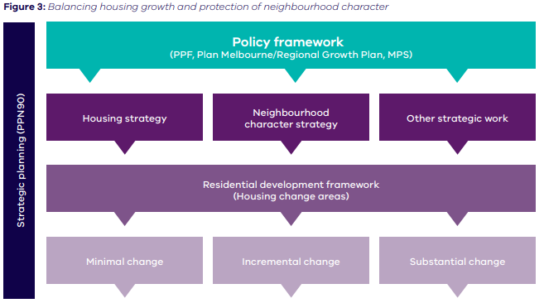
Planning Practice Note 91 – Using the Residential Zones
This PPN provides information and guidance about how to:
- Use the residential zones to implement strategic work (undertaken as part of this project)
- Use local policies and overlays with the residential zones (to implement the changes and recommendations identified throughout this project)
- Make use of the key features of the residential zones.
Strategic context - regional
Both Maldon and Newstead are identified as towns/rural centres by the Loddon Mallee South Regional Growth Plan (2014).
The future growth framework identifies both towns as being within the Bendigo hinterland area, but are not identified specifically as towns/regional centres for managed/ sustainable growth (Map 1, page iii; Map 9, page 41)).
Newstead is located on an identified key linkage between Maryborough and Castlemaine (Map 4, page 14).
Maldon is identified as a significant tourist area (including some significant cultural heritage places and landscapes) (Map 5, page 15).
Maldon is identified as having urban bushfire considerations and aboriginal cultural heritage, places and landscapes, and is located in a declared water supply catchment and an area containing high value terrestrial habitat (Map 8, page 33).
Newstead is identified as having urban flood consideration and urban bushfire considerations, and is located in a declared water supply catchment and an area containing high value terrestrial habitat (Map 8, page 33; Map 9, page 41).
Strategic context – local
The project has been scoped in response to the Council Plan 2021-2025, specifically the following objectives and strategies:
Objective: Our community is growing in harmony with nature
Strategies: Manage sustainable township growth and development
Objective: We are facilitating managed growth of our towns while protecting natural assets
Strategies: Ensure there is sufficient residential, commercial and industrial land to meet demand.
The project aligns with the local vision and direction for the Shire, as set out within the Mount Alexander Planning Scheme. Specifically, Clause 02.03-1 of the Municipal Planning Strategy. The strategic directions of this clause include (as relevant to these townships):
- Discouraging the rezoning of land for urban purposes outside the urban/township boundaries.
- Discouraging the rezoning or development of land for low density residential development if the land is likely to be required for future urban development.
- Encouraging infill and higher density development in the Shire’s towns, particularly in Castlemaine.
- Encouraging growth in townships such as Harcourt, Newstead, Elphinstone and Taradale.
- Limiting urban expansion in Maldon.
This project also responds to various recommended implementations identified as ‘high priority’ within the Mount Alexander Planning Scheme Review, completed in 2019. Specifically, these include:
- Undertake strategic work relating to housing and settlement to update town framework plans to incorporate into the Scheme. (No.5)
- In conjunction with DELWP and CFA, undertake further strategic work to appropriate the BMO – Prioritise Newstead and consider PPN64. (No.13)
- Undertake a neighbourhood character study. (No.17)
- Prepare structure plans for Harcourt and Newstead. (No.18)
Project context
This project forms a component of a broader approach to housing and settlement as set out within the diagram below.
Figure 3: Settlement Planning diagram
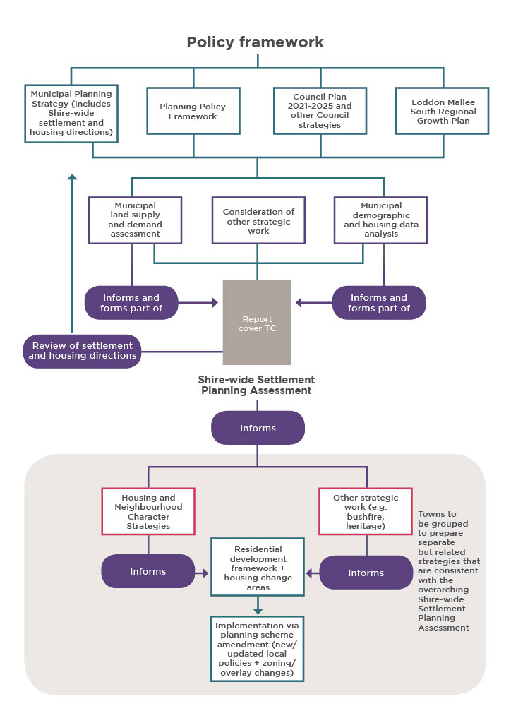
Settlement Planning Assessment
Council has prepared a Settlement Planning Assessment and Municipal Land Supply and Demand Assessment, which is the guiding document to a Shire-wide Settlement Planning Program. This is to include a review of the current Urban Living Strategy, and ultimately create a cohesive framework for managing the future urban growth of the Shire.
The Assessment outlines:
- Maldon will continue to be a key retail centre in the Shire to support residents in the town and surrounding rural areas, and will also continue to serve an important tourist role. Urban expansion will continue to be limited in Maldon due to the bushfire hazards surrounding the town and to protect identified, significant landscapes.
- There are opportunities for new urban development within the existing township boundary, subject to planning controls and guidelines applicable to each site that seek to protect heritage and landscape values (Heritage Overlay, Significant Landscape Overlay, Maldon Design Guidelines) and ensure development addresses environmental risks (Erosion Management Overlay, Bushfire Management Overlay).
- Given that Maldon is also expected to maintain the lowest number of persons per dwelling into the future with a high proportion of lone person households, opportunities to encourage more diverse housing including smaller dwellings should be investigated.
- A review of the residential zoning is needed as the General Residential Zone may no longer appropriate given the State Government’s guidance with PPN 91.
- Further strategic work is needed however to manage and guide future growth including a detailed bushfire risk assessment and flood study (to inform planning overlays) to ensure that development is directed to low risk areas, and a housing and neighbourhood character strategy to address future housing needs and provide clear guidance for future residential development in terms of its location and built form.
Land supply and demand & population forecasting
Key findings of the land supply and demand assessment:
- At a shire level, Mount Alexander Shire has 19 years of supply of residential land, which is sufficient to respond to state planning policy that requires each local government area to have 15 years of residential land supply at any given time. However, the Shire-wide supply does not accurately represent where demand and growth occur within the area.
- There is available land supply of 328 lots in Maldon, which accounts for 9.3% of total land supply in the Shire. Approximately half of this supply is available as existing lots (retail with title).
- There is available residential land supply of 306 lots in Newstead, accounting for 8.7% of the total land supply in the Shire. This excludes areas where flood risk is expected around the Loddon River.

- Project objectives
The objectives of the project are to:
    - Provide direction for where future housing growth is to be directed (including housing diversity options) and make recommendations around the application of the residential zones or other planning controls (in the context of Planning Practice Notes 90 and 91) with regard to the following:
- Constraints to residential land use and development including bushfire, flooding and drainage, contaminated land, waste facilities, and other infrastructure buffers particularly in planning for sensitive uses.
- Heritage places (identified by the Heritage Overlay), and places of significant landscape value.
- Neighbourhood character values (through the preparation of a neighbourhood character assessment). It is important to note that a large portion of Maldon is subject to heritage protection and it is not necessary for additional overlay protection to be applied to these areas for character reasons.
    - Provide more certainty for the community and developers as to the preferred development outcomes for Maldon and Newstead (including housing typology, location and design).
    - Establish a residential development framework for the study area (identifying housing change areas).
- Scope
The study area (see figures 3 and 4 below) is all land located within the existing township boundaries of Maldon and Newstead.

Figure 6: Project study area: Maldon
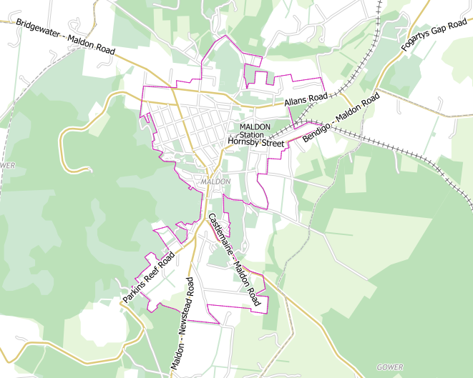

Figure 7: Project study area Newstead
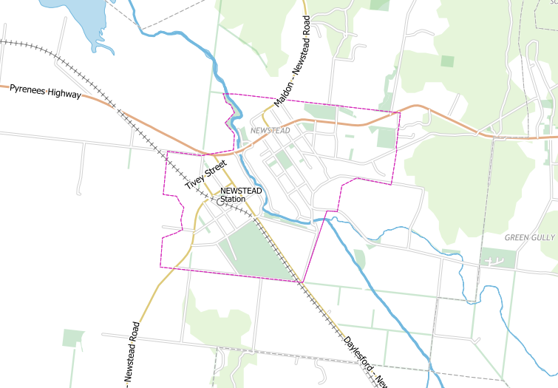

In scope:
    - Preparation of a neighbourhood character assessment where needed given that built form controls and guidance already exists (as the case for most of Maldon).
    - Consideration of the application of the residential zones or other planning controls to provide greater certainty and to encourage a greater diversity of housing in appropriate locations.
    - Updating township framework plans (only to demonstrate outputs from this project but not to amend location of urban boundary).
    - Preparation of a planning scheme amendment to implement the recommendations of the project.
Out of scope:
    - Areas outside of the study area.
    - Investigation as to whether the existing urban boundaries need to be expanded or contracted.
    - Changes to the Heritage Overlay (with the exception of the correction and fix-up of errors and anomalies).
    - Updates to the existing heritage studies applicable to Maldon and Newstead.

